bGeigieNano to bGeigieZen flow
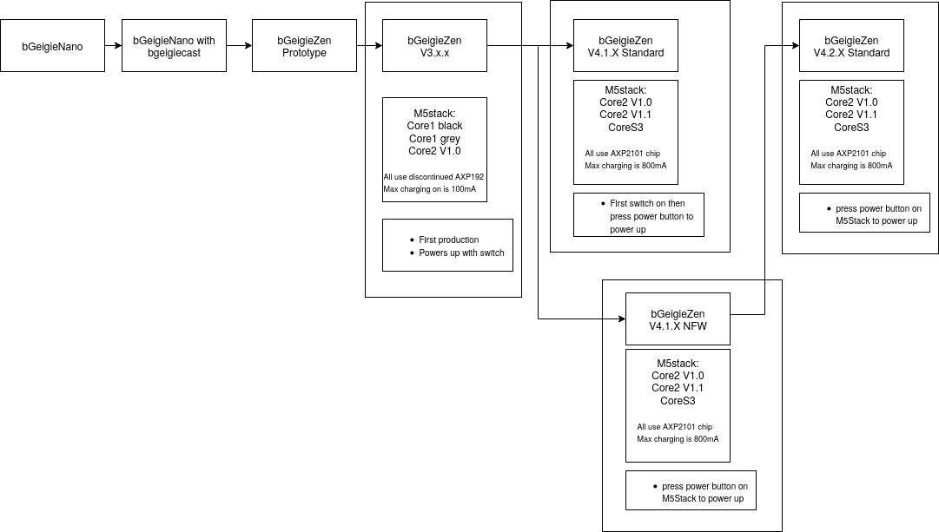

Phase | Date / Version | Milestone & Development Highlights
Concept & Announcement | April 2021 | Safecast officially announced development of the bGeigieZen as the successor to the bGeigie Nano, featuring new SafePulse sensor board and M5Stack platform for simplified hardware and operation (Wikipedia).
Early Hardware Assembly | Early 2024 (v3.0.2–3.0.3) | Prototype PCBs (v3.0.2) arrived and first units were assembled. GPS library and header pin soldering improvements implemented by Michael BeakeS. First Zen units tested in Nara, Japan (bgeigiezen.safecast.jp).
Feature Rollout & Beta Firmware | 2024 | Firmware-enabled clickable audio feedback (“sound upgrade”), ongoing GPS reliability improvements, and continued progress toward fully open‑source hardware/software (Safecast).
Official Launch | Oct 2024 (v4.x.x) | Launch announcement of bGeigieZen with Wi‑Fi / BLE connectivity, color touchscreen, replaceable battery, USB‑C, and live upload features (safecast.org, bgeigiezen.safecast.jp, safecast.org).
Software & App Updates | Feb–Mar 2025 | Development of bGeigie‑Drive app nearing beta; real-time logging and GPS troubleshooting tools added; testing on real‑world events like BAJA 1000 rally; sensors deployed near Pickering Power Plant (bgeigiezen.safecast.jp).

🧭 Summit Highlights:
- Simplified build: Reduced from ~60 parts to ~18; assembly time cut to ~20–60 minutes; no soldering required for most components (bgeigiezen.safecast.jp).
- Better hardware: M5Stack Core processor, improved 320×240 color display, upgraded GPS (Beitian module, evolving to BZ-251/M9), larger onboard storage, and expandable I²C support (bgeigiezen.safecast.jp).
- Enhanced user experience: Audio click feedback, OTA updates, BLE/Wi-Fi connectivity, USB‑C port—all designed for accessibility and robustness (Safecast, safecast.org).

📦 GitHub Evolution Notes
Safecast’s GitHub activity shows evolution from prototype boards (v3.x) through to stable v4.x firmware, with contributions by Michael BeakeS on GPS code and community-driven improvements visible in repository commits and discussions. Though specific commit logs require direct inspection on GitHub, the milestones above reflect publicly announced development phases (bgeigiezen.safecast.jp).

Interpretation & Community Context
The bGeigieZen represents a shift toward more accessible radiation monitoring tools—reducing barrier to entry, enhancing real-time data capabilities, and reinforcing Safecast’s open‑source ethos. Its development timeline showcases strong community involvement, rapid iteration, and real-world field testing in diverse settings.
Let me know if you'd like deeper insight into GitHub commit logs, firmware release notes, or technical specs for any particular version!

